**Liquid Crystal Imaging Software – Functional Design Document**

**Table of Contents:**

1. Introduction

2. Development Environment

3. System Requirements

4. Software Architecture

5. Software Usage

5.1 Contour Generation Module

5.1.1 Contour Generation Flowchart

5.1.2. Backend Procedure for Contour Generation

**1. Introduction**

The goal of this prototype software is to be able to provide user with the ability to generate contours of Hue, shear stress, skin friction, etc. on images of liquid crystals applied on surfaces with shear, calibrate liquid crystals based on experimentation and generate characteristic curve for Hue vs Shear Stress for different crystals. The modules that are currently available are:

1. **Contour Generation**

- This module is used to generate contours of a required property (Hue, R, G, B, Shear stress, etc.) on the chosen image.

- The user can upload an image, select a portion of the image and generate the contour of the required property like Hue, Shear stress, etc. and the save the image in the required resolution.

1. **Hue vs Shear Stress calibration (under development)**

This module will have the capability to be able to generate a Hue vs Shear stress curve that can be used to calibrate a particular liquid crystal so as to be able to be used in the contour generation module.

**2. Development Environment**

The package has been developed using Python 3.9.0 running on a virtual environment with the following packages installed:

1. Numpy – For handling arrays
2. Scikit Image – For handling scientific computations on image arrays
3. OpenCV, PIL – To perform image manipulations
4. Matplotlib – To visualize charts and images
5. Os – For interacting with the operating system like opening files and folders, etc.
6. PyQt – For creating and handling UI elements

**3. System Requirements**

**Processor**: x64 64-bit CPU (Intel / AMD architecture)

**Disk space**: 5 GB of free disk space

**RAM:** 2GB RAM (4GB preferable)

**Operating systems**: Windows* 7 or later, macOS, and Linux

**Python* versions**: 3.6.X

**4. Software Architecture** **Backend:**

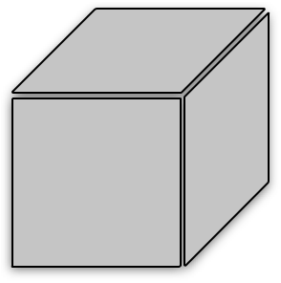**Frontend:**



Application

UI

Contour Generation Module

- Reads image

- Resizes it to chosen resolution

- Converts it into required format

- Detects contours of the chosen variable

- Plots the contour onto the image

- Saves the final image with contour and value labels

Hue Vs Shear Stress Calibration

Module

(Under development)

- Accept LC image files

- User can input the Shear stress value for a particular Hue image file

- Build Hue vs Shear characteristic curve for the particular LC

- Use it in contour generation to plot shear stress contours

- Built using PyQT designer

*Fig 1. Software Architecture*

The software package has been setup as modular by splitting the different components into separate python modules such that it is scalable and any changes or new features could be added easily.

1. The UI module is separate (in this case LC_Software.py) and the module for contour generation and other functions are separate. The modules are in .py python format and they need to be placed in a single folder before the run. The directory structure is given below:

|--- Liquid Crystal Folder

|--- LC_Software.py

|--- Contour_Generation.py

1. Also the python modules (e.g. Numpy, Scikit, PIL, OpenCV, etc.) discussed in section 2 have to be installed along with the python installation and this is done using python package installer pip.

**5. Software Usage**

Once all the modules have been installed, the application can be run as shown in fig. 2.

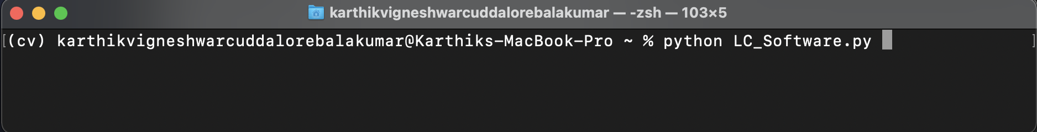*Fig 2. Mac Terminal Command Line*

Fig. 2 shows a command line from Mac Terminal which has been used to run the software. Here the LC_Software.py is the main python module that fires up the LC Software UI as shown in fig.3.

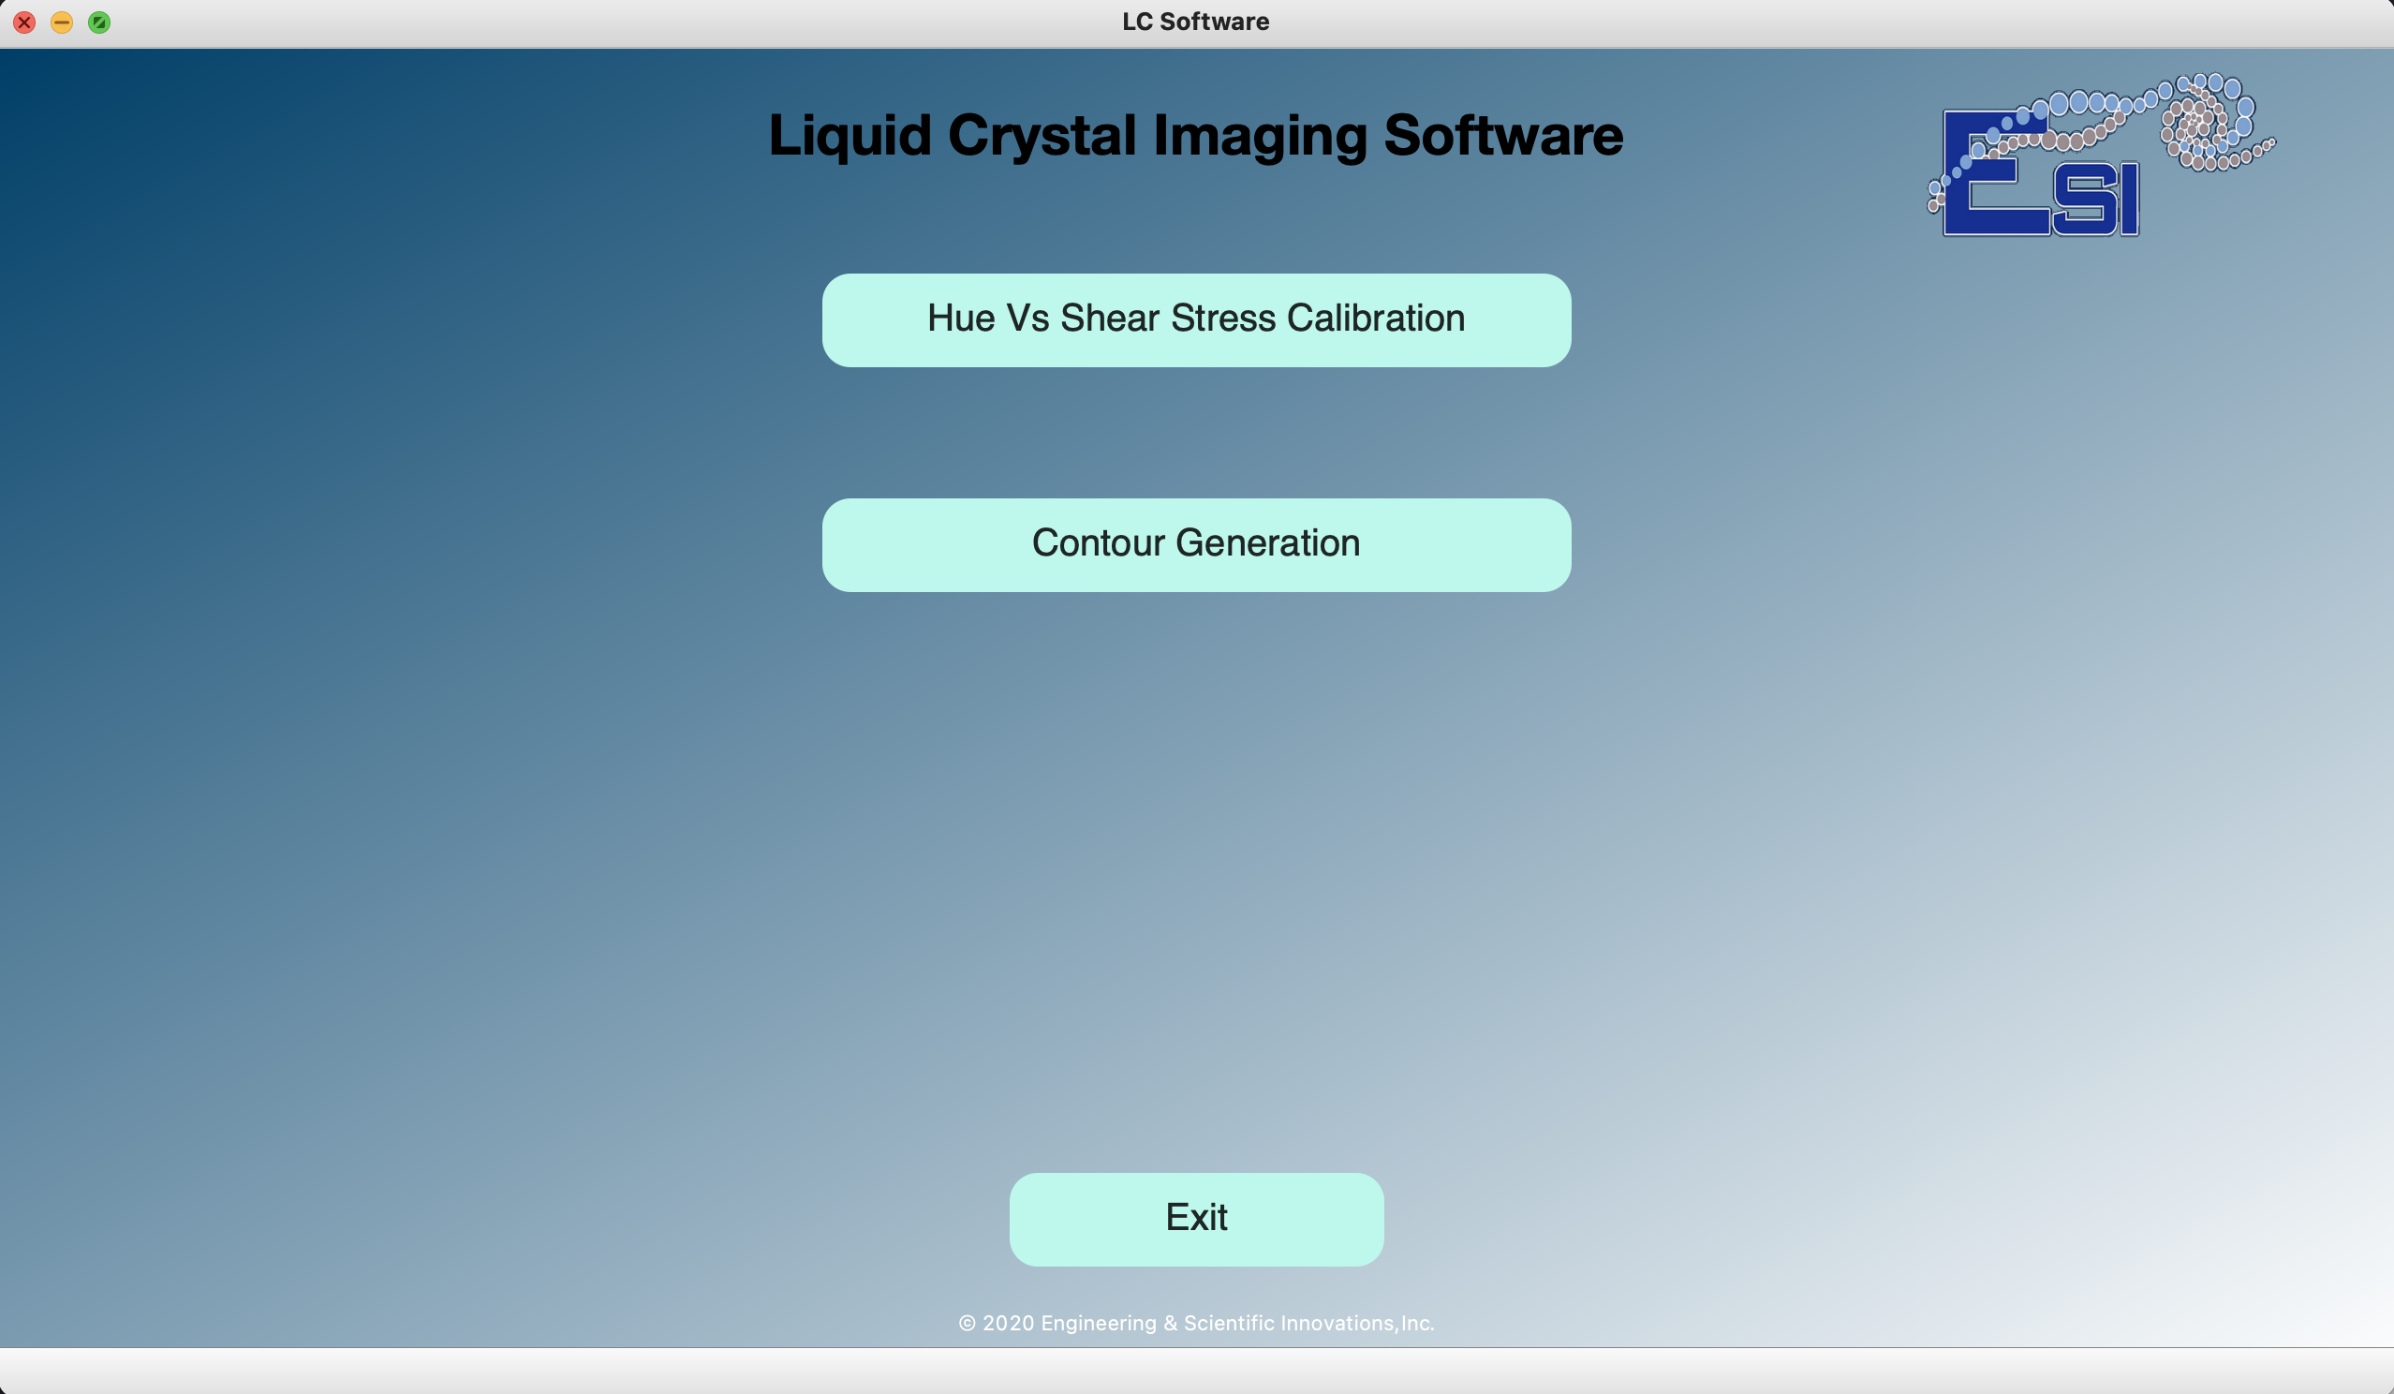

*Fig 3. LC Software Startup Page*

**5.1 Contour Generation Module**

The contour generation module is used to generate contours of required variable (e.g. R, G, B, Hue, Shear Stress, etc.) on a given image. There are different options that the user can select in the contour generation module. These are shown in fig. 4.

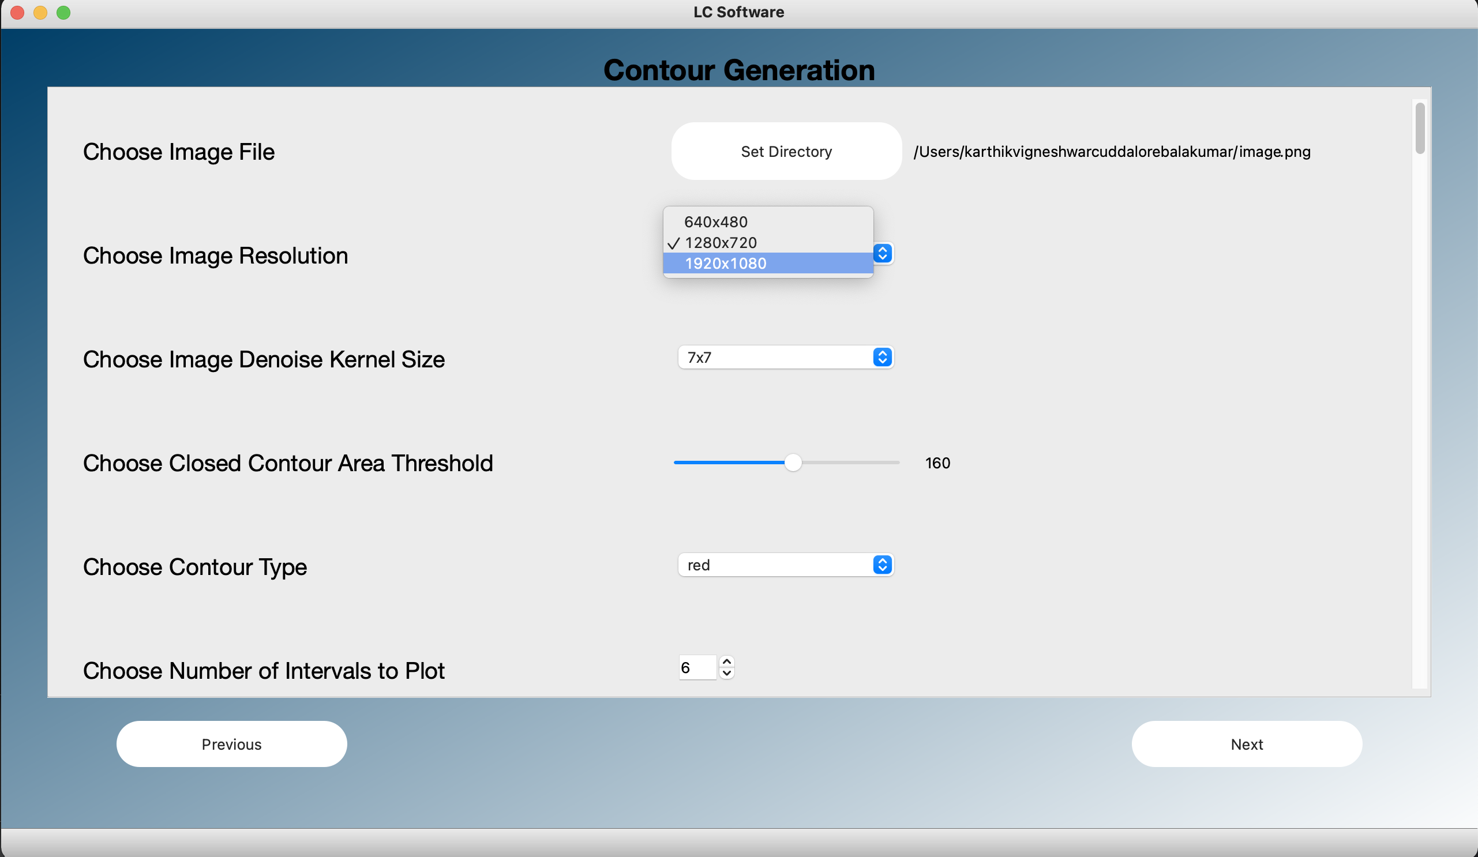Fig 4. Contour Generation Options

**5.1.1 Contour Generation Flowchart**

The contour Generation flowchart is shown in fig. 5.

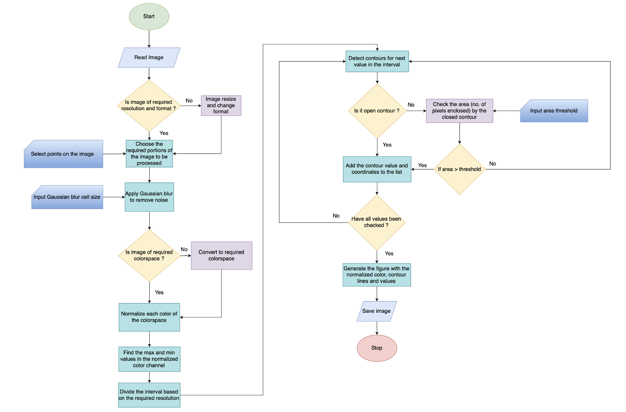Fig 5. Contour Generation Flowchart

1. The Contour Generation module page shown in fig. 4 consists of various required options for processing image and generating contours. The user can select the image directory, the image to be processed, the final resolution of the contour image, the kernel size for image denoising, closed contour area threshold, plotting interval and the option for which the contour plot needs to be generated (e.g. red, green, blue, hue, shear stress, skin friction, etc.).
2. The next button opens up the window where the user can select the ROI on the chosen image on which the contour lines have to be plotted.
3. The user options are saved when next button is pressed and the chosen image opens up after getting resized according to the chosen resolution as shown in the fig. 6.

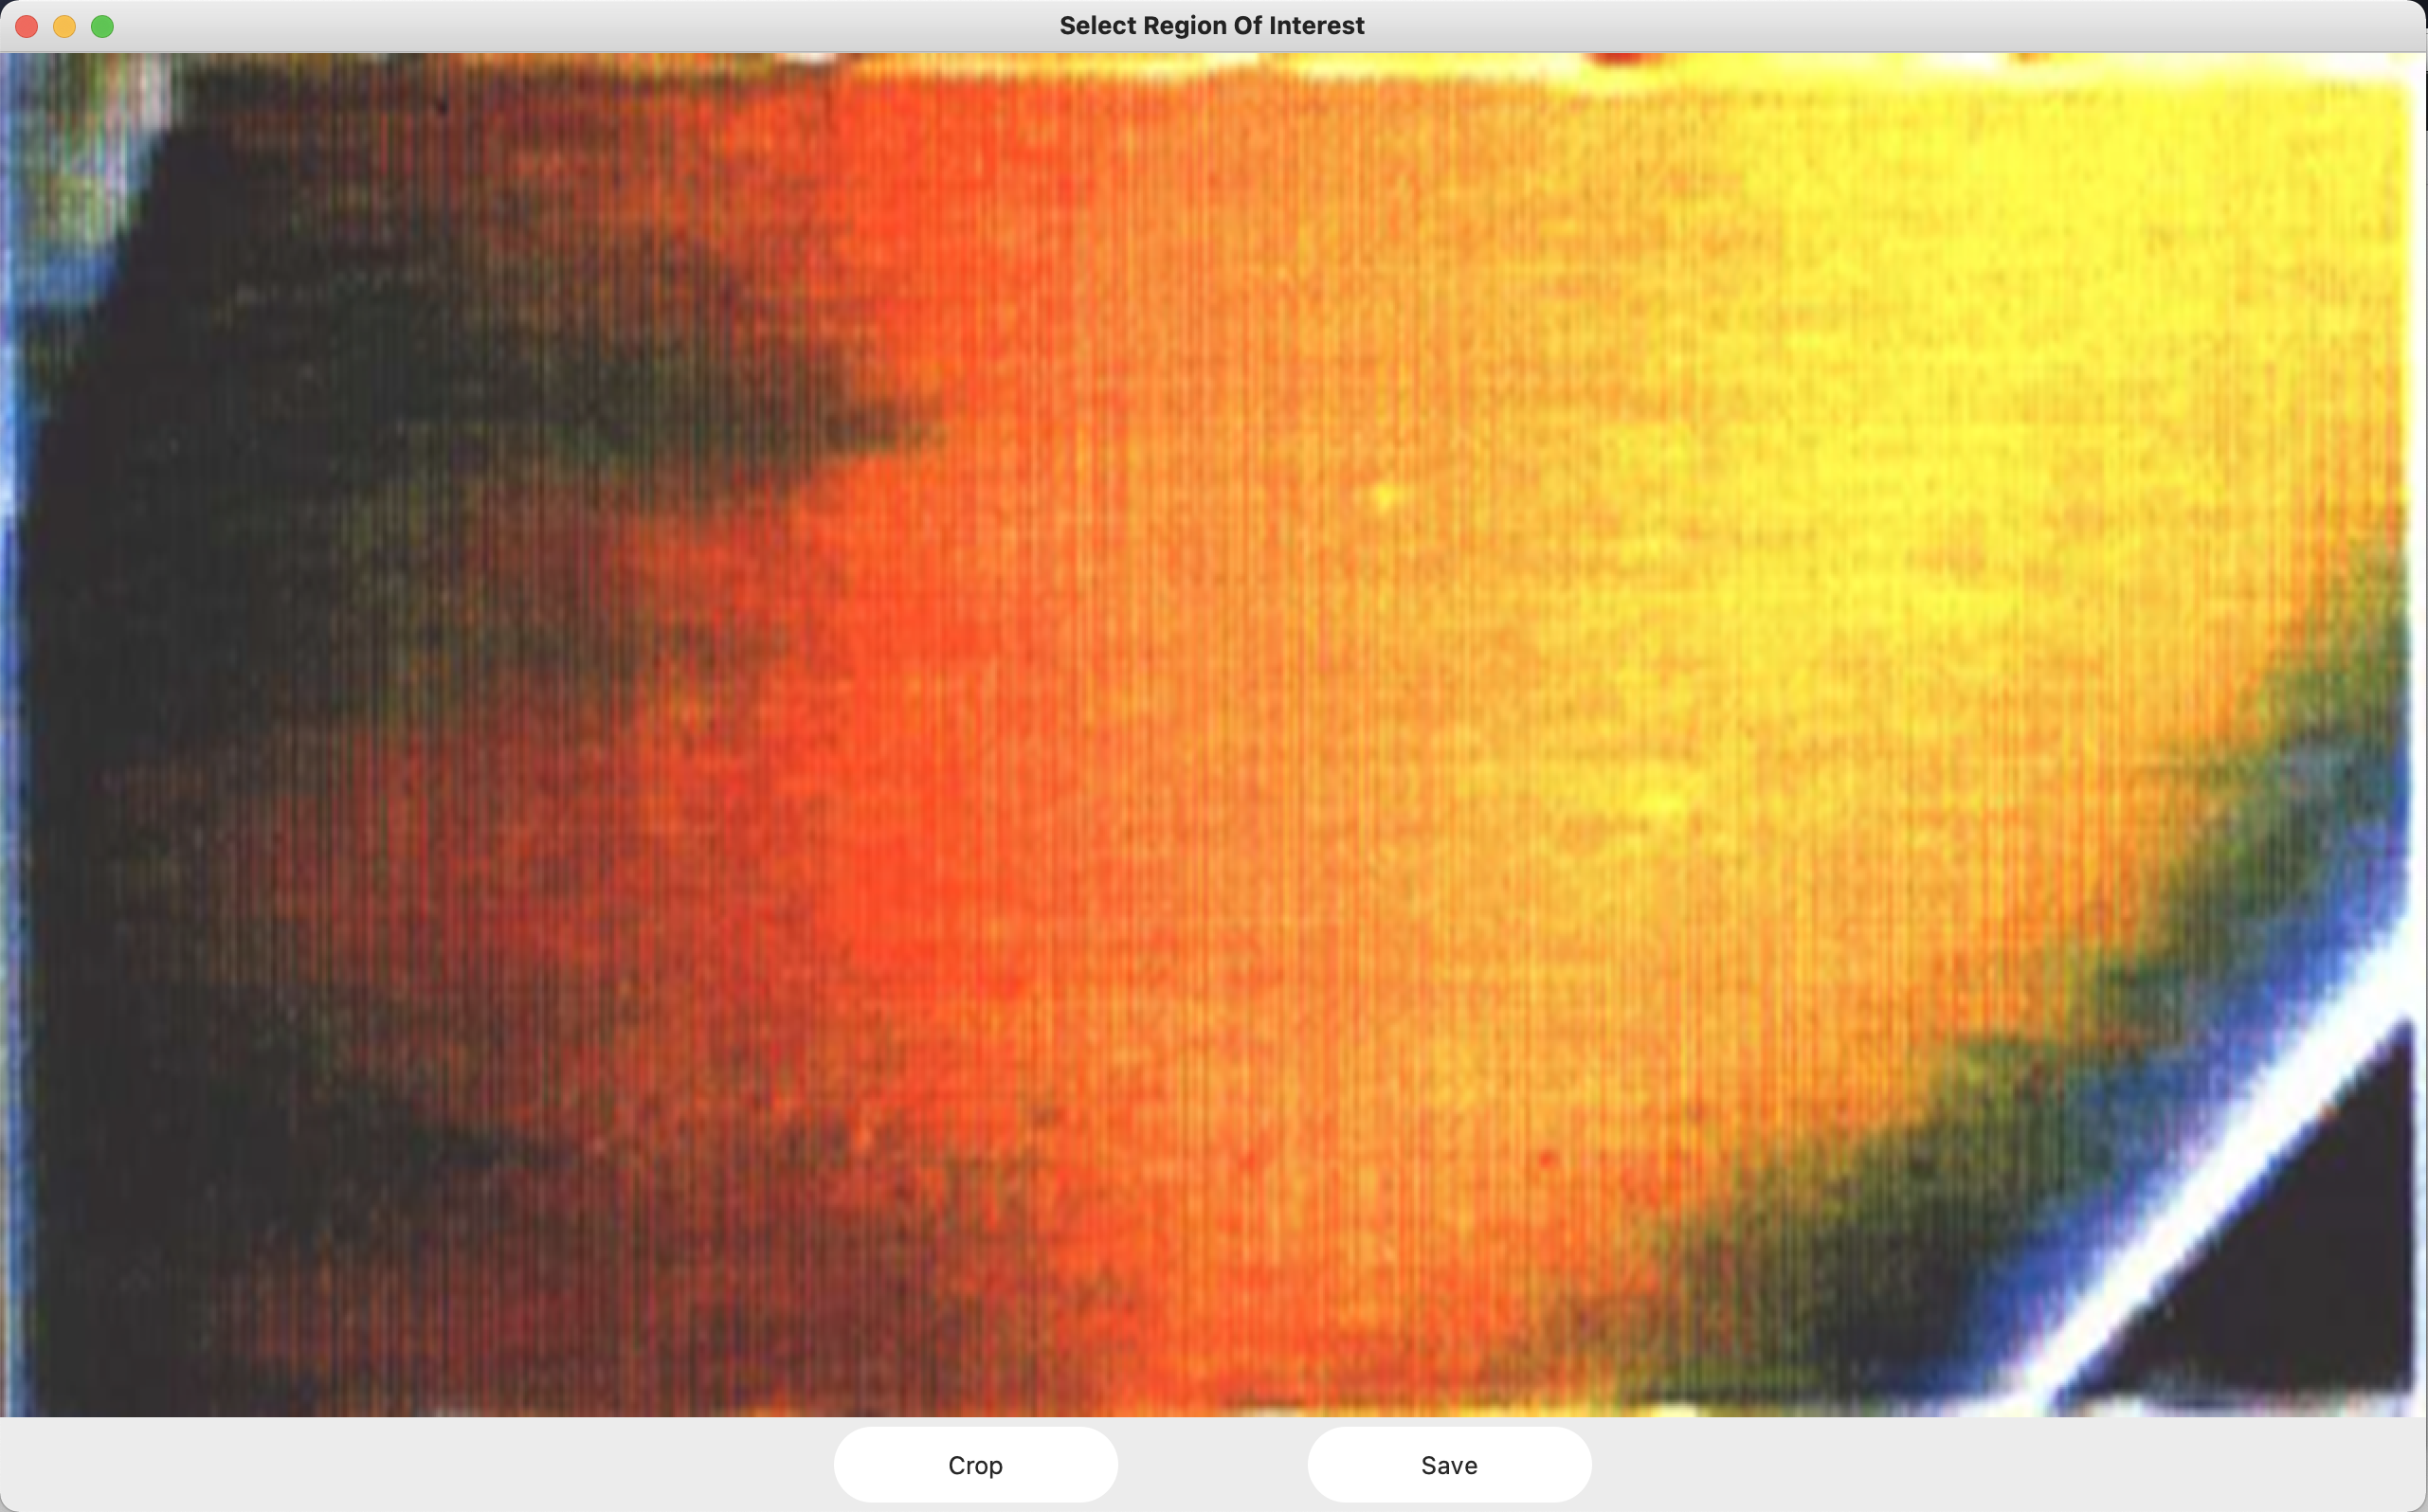

Fig 6. New window to select ROI

1. The image region (ROI) on which the contour plot needs to be generated can be chosen in this window. This is done by pressing the left mouse button and dragging a rectangle inside the image and positioning the rectangle region to which the image needs to be cropped as shown in fig. 7.

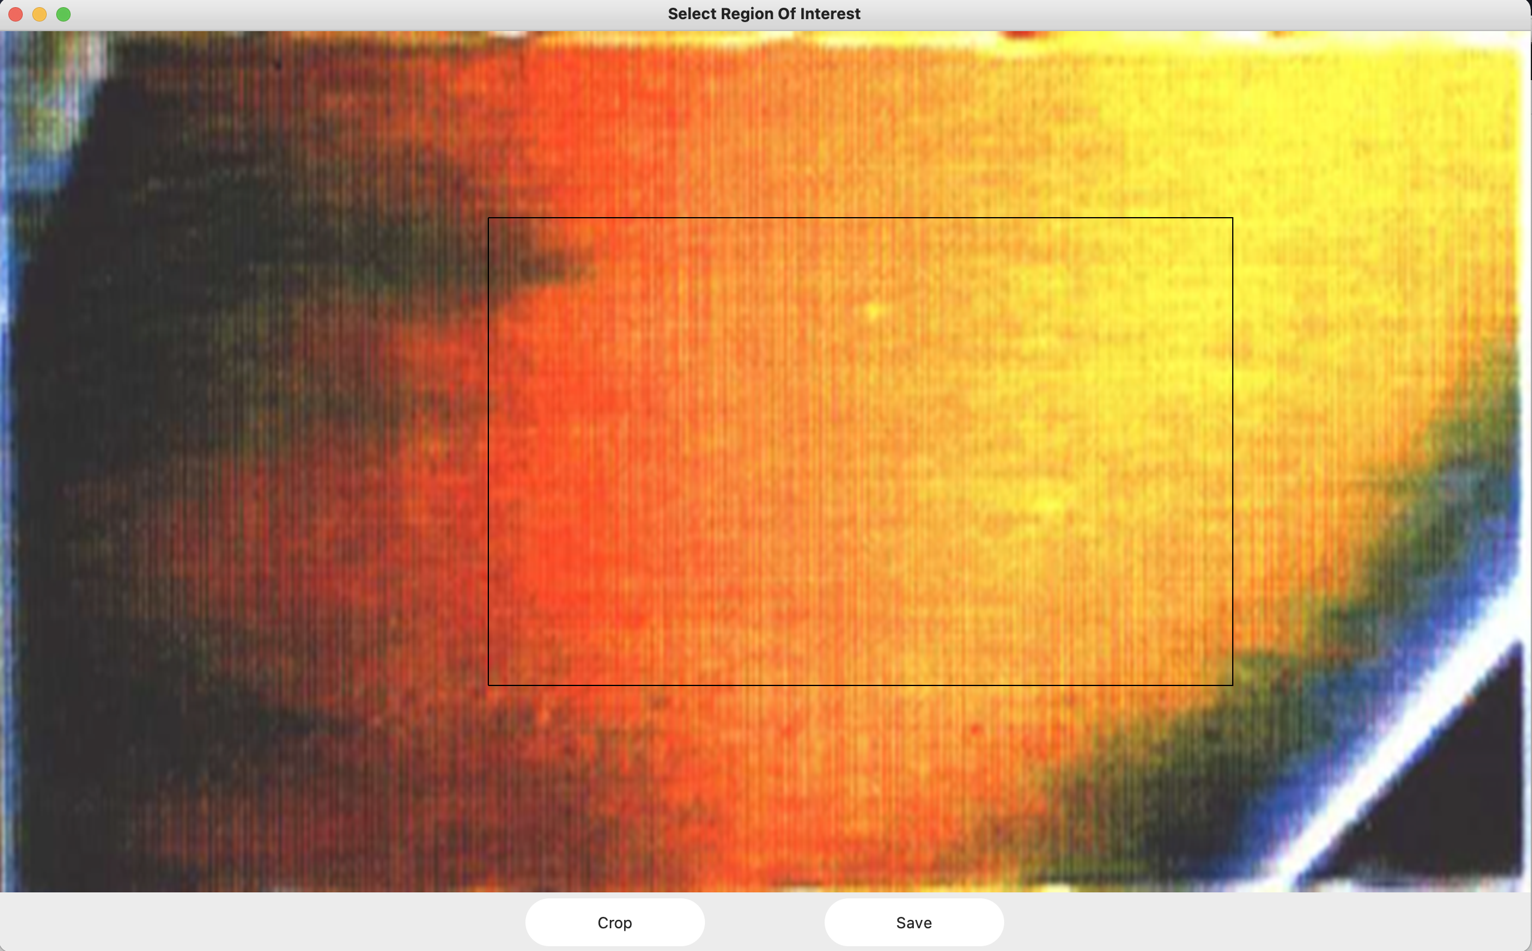

Fig 7. Selecting rectangular ROI using mouse click and drag

1. The rectangle crop region can be reset by left clicking on the image again and a new crop region can be selected.
2. Once the crop button is pressed, the image ROI is saved. Pressing the Save button saves the image in the current working directory.

**5.1.2 Backend Procedure for Contour Generation:**

1. A gaussian blur of the selected size (pixels x pixels) is applied in order to remove the high frequency noise from the image.
2. The image is then processed as default RGB or converted to HSV based on the user selected option for the contour plot.
3. The image is 3-channel in both the formats and the channels are split into individual arrays.
4. Once the individual channels are obtained (R, G, B or H, S, V), the channels are normalized by dividing each pixel value by the maximum allowed value in OpenCV.
5. For example let us say that the user chose the option for Red contour to be plotted. The Normalized Red array is calculated for the every pixel in the image and the maximum and the minimum values are obtained.
6. The values are then split into the required number of intervals (e.g. 4 in our case) and the contours in the image are detected for these values in the intervals.
7. The pixel coordinates of each contour is stored in an array to be used for final contour plot.
8. There are basically two types of contours – Open & Closed. Open contours do not close in on themselves, and they end in any one of the boundary edges of the image. Closed contours on the other hand have the same start and end points meaning they form a closed loop.
9. Once the contours are detected, the contour properties like the area (no. of pixels inclosed by contour), centroid (for closed contours) and the end points of open contours are stored in respective arrays.
10. In case of the closed contours, in order to avoid numerous small blobs of closed contours in the final processed image, we set a threshold value for the minimum area (no. of pixels) required to be enclosed by the contour. If the contour is smaller than this threshold then it is not plotted in the final contour image. This is shown in fig. 5 where the first image has a lot more number of small closed contours when compared to the second one because of the smaller criteria for threshold area. The value of this threshold can be chosen in the GUI.

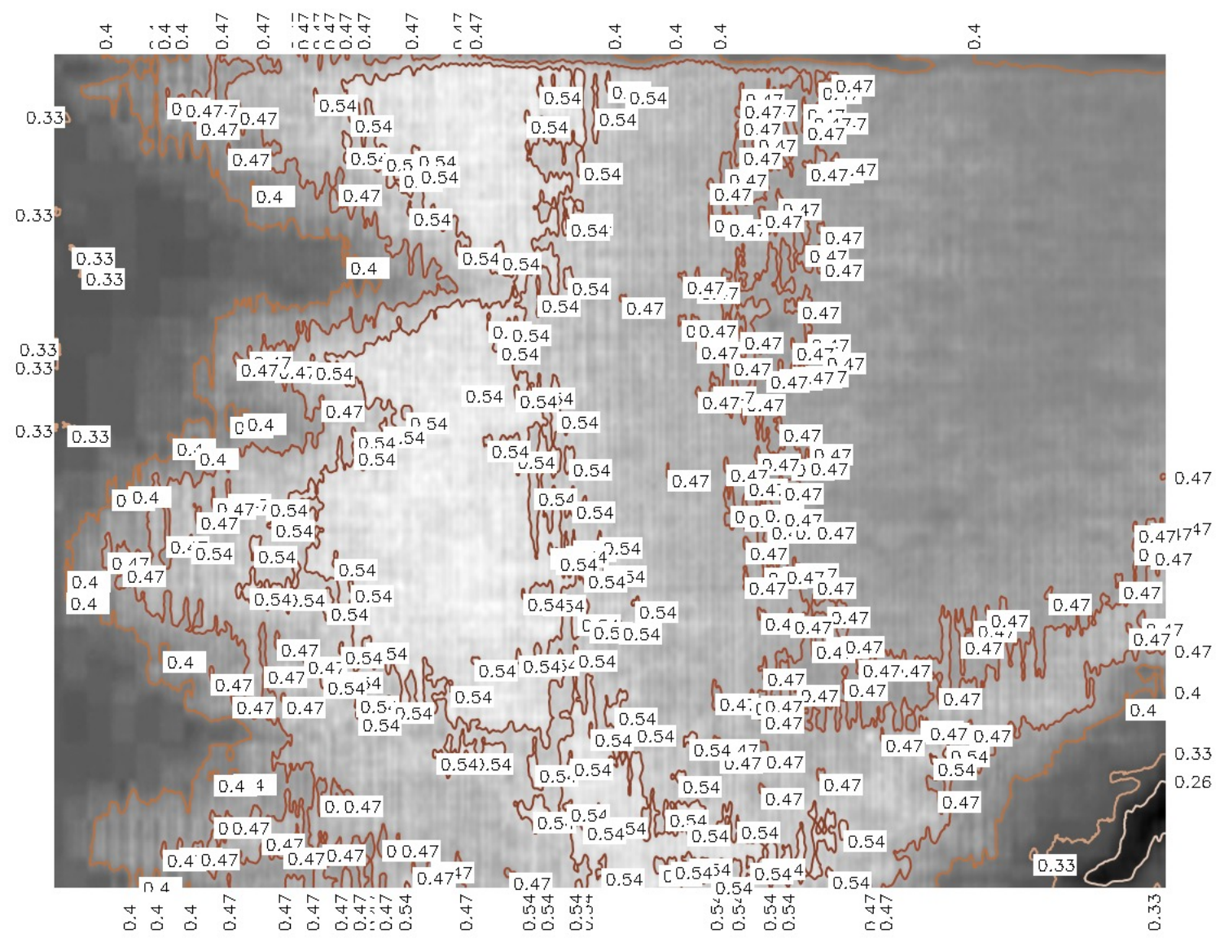

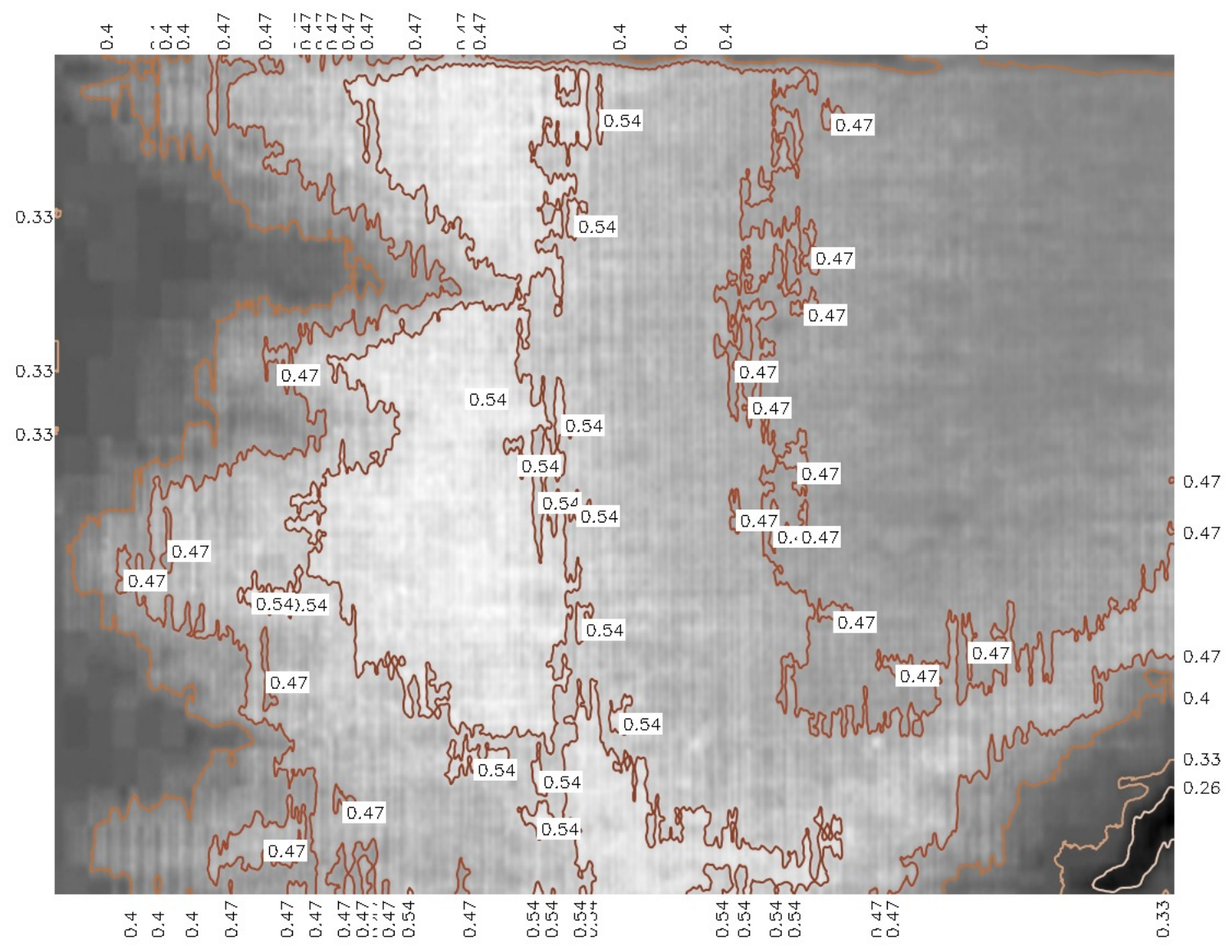

Fig 8. Contours generated with different closed contour area thresholds (top & bottom)

1. The next step is generating the labels for the contour values that need to be placed next to the contour in the final image. The labels of the contours are generated for every value for which the contour was generated.
2. The contours are plotted on to a grayscale image, and the value labels are added next to the contours edges (in case of open contours) and at the centroid (in case of closed contours).
3. Once the processing of the final contour plot is completed, it is saved as an image in the same format as that of the input image as shown in the fig 6 below.

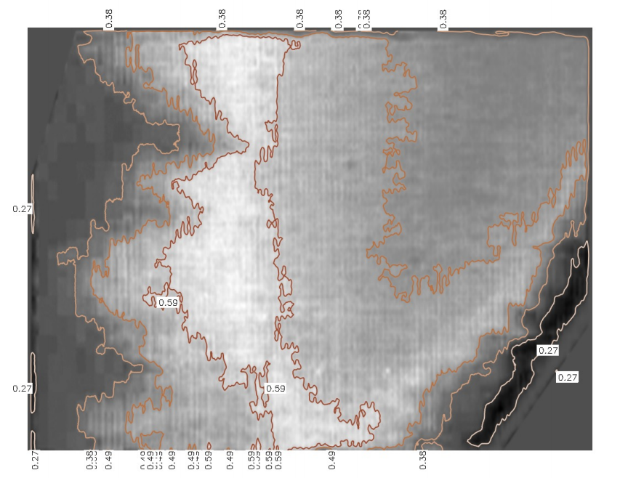Fig 9. Final Contour lines for normalized red generated over the grayscale image